**EMAIL**

**DIAMOND WOMAN; EVERY WOMAN!**

Dear [Customer Name],

As a Diamond Woman – a woman within the Diamond Family, we are pleased to inform you that you have been profiled on the ***Diamond Woman*** online community.

Being a member of the Diamond Woman online community gives you access to a vibrant and interactive community via a dedicated website with lots of information on financial, health, career and other business related matters.

It also provides a highly engaging platform for you to share interesting tit-bits and experiences with other women you can relate to.

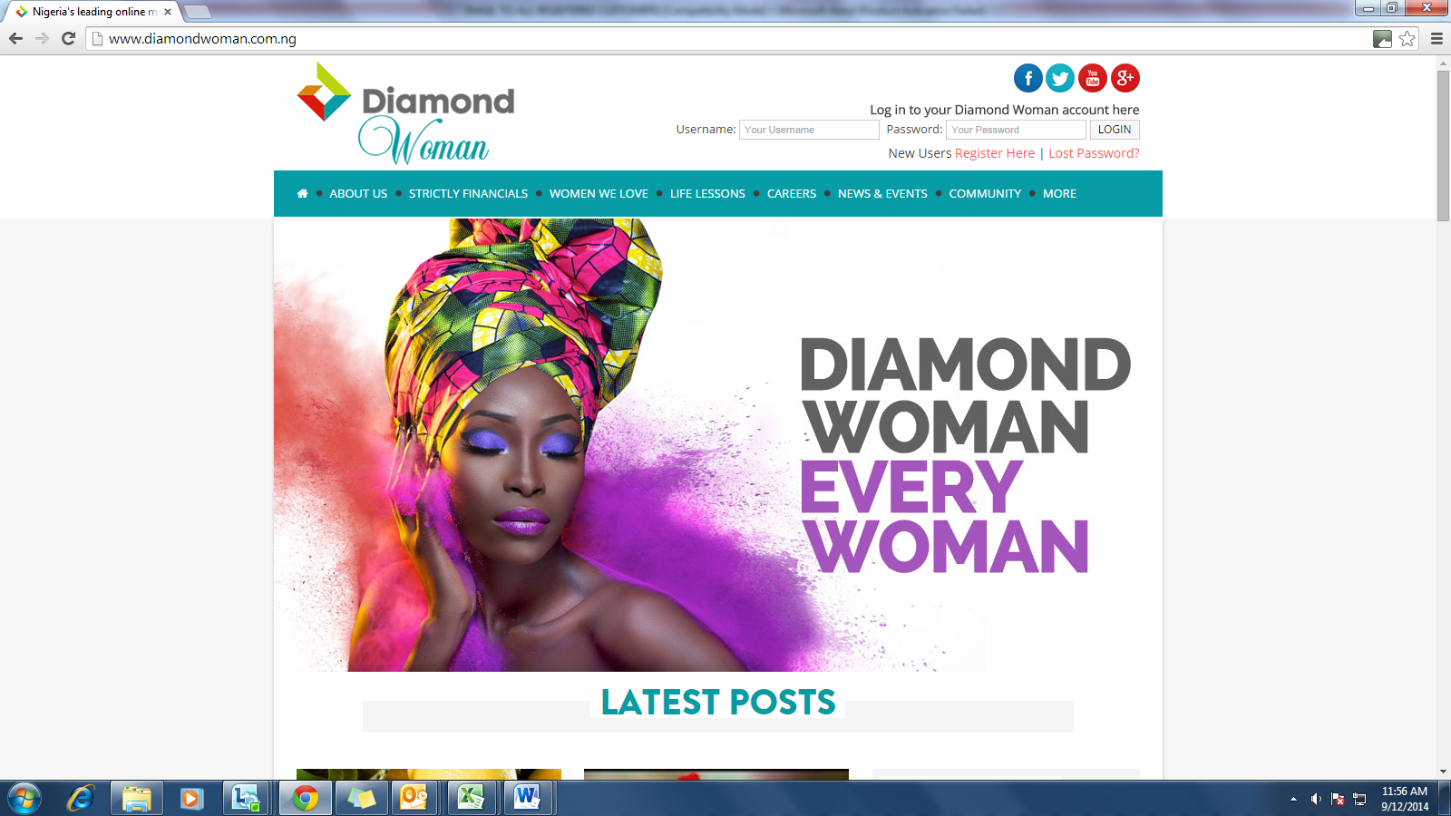

Activate your profile on the ***Diamond Woman*** online community today and experience a world of exciting interactions and benefits.

1. ***Visit*** [***www.diamondwoman.com.ng***](http://www.diamondwoman.com.ng)
2. ***Click on ‘Activate’, and enter your email address in the box provided to activate your profile.***
3. ***Join the conversations***

Look out for more exciting benefits courtesy ***Diamond Woman***.

For enquiries, please call 0700 300 000 or send an email to [diamondwoman@diamondbank.com](mailto:diamondwoman@diamondbank.com) or enquiries@diamondbank.com.

***Diamond Woman…Every Woman!***

**SMS**

Dear [Customer Name], as awoman within the Diamond Family, we are pleased to inform you that you have been profiled on the Diamond Woman online community. Please visit [www.diamondwoman.com.ng](http://www.diamondwoman.com.ng) to activate your profile and enjoy exciting interactions and benefits.For enquiries, please call 07003000000 or SMS 30811